Get your pub on the list
CAMRA is pushing to get over 300 pubs listed as Assets of Community Value in 2013

High property prices mean pubs are being targeted for conversion into supermarkets, fast food outlets, and housing developments. Sometimes this is inevitable where no-one uses a pub anymore and it has served its useful purpose. However, there are other cases where local communities are fighting threats to their valued local. Too often these threats can come out of the blue – a real nasty surprise. However, there is now something to help communities avoid such a nasty shock.
Pubs under threat: is there anything you can do about it or do we just sit back and watch your local pub die!
Listing a pub as an Asset of Community Value with the local council means a pub can’t be sold on without the local community being told. It gives the local council greater ability to refuse planning applications from developers and gives the local community up to six months to put in a bid to buy the pub, should it be put up for sale.
Under the provisions of the Localism Act, interested communities (both rural and town) can now apply to the council to have their local pub registered as an ASSET OF COMMUNITY VALIUE (ACV).
So, what does this mean?
Stops a sneaky sale – the community will know.
Once a pub is listed as an ACV it cannot be sold without the knowledge of the local community – a major safeguard against ‘nasty surprises’, and if a local community decides to get organised the clock can be stopped for up to six months to allow them to work-up a bid to buy the pub.
Puts a stake in the ground by saying: this is a community pub!
Listing a pub is also hugely beneficial in planning terms. It lays down a clear marker that a pub is an important community amenity. Should the pub be subject to a planning application at some point, then the fact it is listed as an ACV is highly material. No would-be developer can easily argue it isn’t a vital community facility.
How do you list YOUR local?
- Go to the section of local council website i.e.
www.eastdevon.gov.uk/communityassets
www.exeter.gov.uk and search Community Assets

- Download a nomination form. This should be completed with as much detail as possible covering why your pub merits being designated as a community asset.

- Get supporting signatures from at least 21 people. They will need to be pub-users, live locally and be on the current electoral register.

- Send it off to your local council. It is their duty to consider the application (against prescribed criteria) and respond in due course
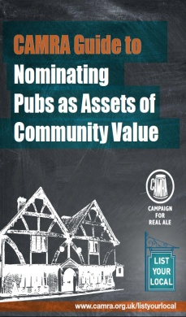
A CAMRA Guide to Nominating Pubs as Assets of Community Value and other advice and support on registering a valued local pub is available and can be down loaded from the CAMRA website at www.camra.org.uk/listyourlocal

Now is the time to act: whether your valued local pub is in the back streets of Exeter or in a small village. CAMRA believes it is essential that communities don’t leave their local pub exposed to the whim of opportunist developers. Remember, that’s the very reason this legislation was put on the statute books in the first place – so use it!

